PS lab - IT24101905

Lab Exercise 6 (Discrete Probability Distributions)

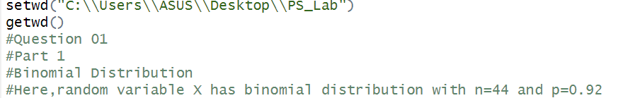

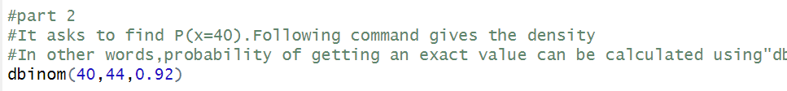



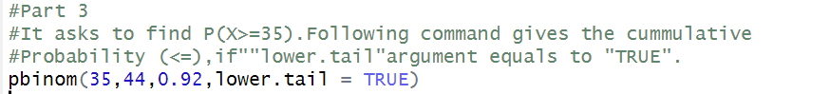

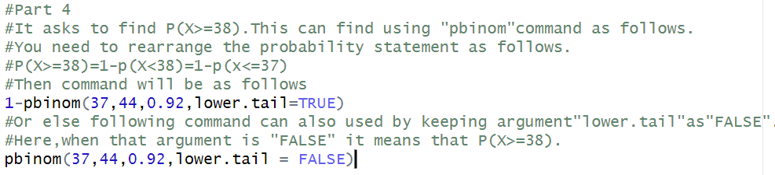

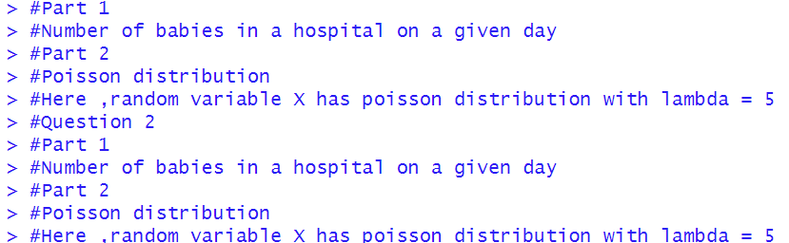



Exercise



